Windows 2000 Networking and Troubleshooting -- Main handout
--Lenny Bailes

Day 1 -- System Architecture

DOS and Windows 3.1
- DOS is generally a single tasking or task-switching operating system
- Windows is a graphical user interface (The A+ course calls it a graphical working environment.)
- Windows 3.1 had limited multitasking
It used two virtual machine structures, one for all of the Windows applications, and another for each DOS app. 16-bit Windows apps had to fight for CPU time with each other according to their inbuilt programming all within a single virtual machine.
- Windows 3.1 and 95/98/ME cycle between open DOS virtual machines, according to internal operating system settings
- Windows 3.x loaded on top of MS-DOS. It was activated by typing WIN at the command prompt or by inserting a WIN command in AUTOEXEC.BAT.

Windows 95/98
- Windows 95 integrated the DOS core and the Windows graphic interface more closely.
The command to load WIN.COM (the graphic interface) was added to the IO.SYS boot loader file.
- Windows 95 is a 16-bit/32-bit hybrid operating system.
It retains compatibility with 16-bit Windows 3.x applications and includes a new virtual machine to run the faster, smarter 32-bit apps. (Microsoft Office 4.3 was the last 16-bit version. In Microsoft Office 95, 97, and 2000 all of the applications are 32-bit.)
- Unlike 16-bit Windows apps, 32-bit Windows 95/98/ME programs each run in a separate protected memory space.
The operating system can intelligently monitor and control program requests for CPU time. (This is called pre-emptive multitasking.)
Additionally, Windows 95/98/ME can manage multiple processes within a single program. For instance, if a program accepts keyboard input and sends information to the printer at the same time, Windows 95/98/ME can separate program instructions into multiple threads, each one using its own slice of CPU time.
This control of single-application performance is called multithreading. )
If a 32-bit application crashes, it's much less likely to take the whole operating system with it and make you reboot the computer.
Windows NT offers even more application protection, isolating 16-bit programs as well as 32-bit programs.
- Windows 95/98 is also different from Windows 3.x in its user interface. The Program Manager and File Manager windows are replaced with a unified desktop patterned on the Macintosh. The new desktop can contain floating icons, application windows, file windows, and DOS sessions, all within the same space.

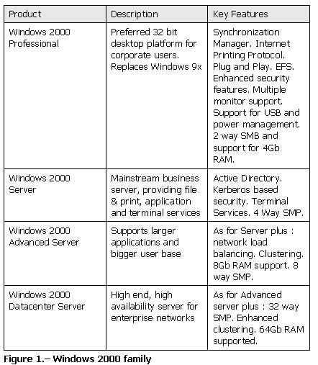
Windows 2000 combines the application protection and security features of Windows NT 4 with the plug and play capabilities of Windows 9.x

Lab Exercise 1 - What's new in Windows 2000
Lab Exercise 2 - Microsoft Management Consoles
Disk Manager is the old Disk Administrator and is a snap-in. It can be used to defragment, create, and manage volumes and disks. Disk systems now support FAT32, NTFS, and FAT. The convert.exe utility can be used to convert a FAT or FAT32 partition to NTFS. NTFS partitions cannot be converted to FAT or FAT32. If such a need exists, the partition must be deleted and recreated as FAT or FAT32.

The NTFS file system has many new capabilities as follows:

# EFS - Encrypted File System. Windows 2000 NTFS volumes have the ability to encrypt data on the disk itself. This is based on public key and private key encryption procedures. Private keys are used to encrypt and decrypt files, and the key can be placed on a floppy disk for transport to other machines. The CIPHER command can be used for encrypting from a command line. Only the user that stored the file can open it again or a recovery agent. Taking ownership of an encrypted file will not let you read it. Cipher.exe is a command line utility that allows for bulk or scripted file encryption. To enable a folder to have any new contents encrypted, simply view the property page for the folder and select "Encrypt contents to secure data".
# Disk Quotas - Provides the ability to set space limitations on users on a per volume basis. The ownership of a file determines which user to charge the space used against. You must enable quota management from the properties dialog - quota tab of a given disk. You can then set thresholds for individual users including a warning level when their files exceed a certain amount of storage that is approaching their quota limit.
# Defragmentation - Windows 2000 now includes a disk defragmenter that can be used on NTFS partitions.
# Volume Mount Points - Provides the ability to add new volumes to the file system without having to assign a drive letter to them. This feature is only available on an NTFS partition using dynamic volumes.
Lab Exercise 3 - Using the Windows 2000 Task Scheduler
Lab Exercise 4 - Using the Windows 2000 Registry editors and saving the Registry
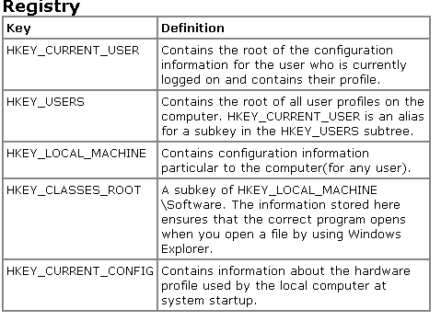
The registry editors included with Windows 2000 include Regedt32 and Regedit. Each registry editor has advantages and disadvantages. You can perform most tasks with either registry editor, but certain tasks are easier with one registry editor. The following are advantages of Regedt32:
* Using the Security menu, you can check for and apply access permissions to subtrees, keys, and individual subkeys.
* Each subtree is displayed in its own dedicated window, reducing clutter.
* You can set an option to work in read-only mode.
* You can edit values longer than 256 characters.
* You can easily edit REG_MULTI_SZ entry values.
* You can load multiple registry files at the same time.

The following are advantages of Regedit:
* Regedit has more powerful search capabilities.
* All the keys are visible in one Windows Explorer like window.
* You can bookmark favorite subkeys for fast access later on.
* Regedit reopens to the subtree that was last edited.
* You can export the registry to a text file.
* You can import a registry file from the command line.
How Do I Keep Win 2000 Current?
Q: How do I keep Windows 2000 current?
A: Windows without a bagful of bugs just wouldn't be Windows, now would it? If you want to keep Windows 2000 operating at maximum efficiency, you need to stay on top of bug fixes, patches, plugs for the inevitable security holes, and other OS tchotchkes. That's where Windows Update comes into play.
Select Windows Update from the Start menu or use your browser to go directly to the Windows Update site. (Unless you've customized Start, Windows Update should top the menu.) An ActiveX component loads, scans your PC, determines which updates you need, and then displays a list customized to your computer. The Critical Updates category is, of course, the most important; generally these are security fixes or massive service pack updates
Don't blindly take Microsoft's advice to install a bunch of stuff, however: Before you download anything, click the "Read this first" link at the end of the download's description for more information about why you should install a file, how much disk space it requires, and how to uninstall it (if that's even possible).
Lab Exercise 5 - Creating W2K Emergency Restore disk and activating the Recovery Console

Working in Windows Control Panel
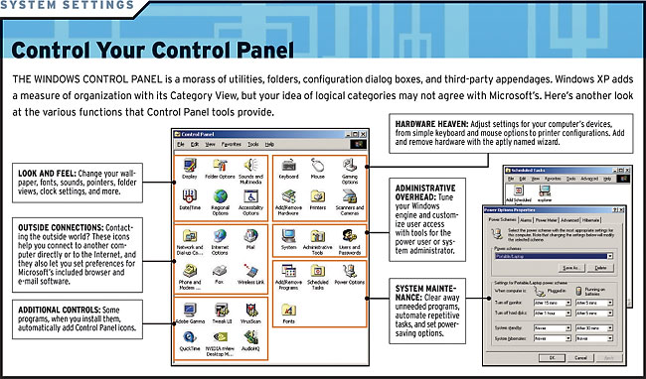
See http://www.pcworld.com/features/article/0,aid,104690,pg,5,00.asp

Windows 2000 Professional Setup

See: http://howto.lycos.com/lycos/topic/1,,9+50+26738,00.html
http://ftq.itpoints.com/w2kp/
http://www.techtutorials.com/tutorials/2000/win2kpro.shtml#install

The following are the installation requirements for a Windows 2000 Professional workstation:

* 133 MHz or higher Pentium-compatible processor
* 64MB minimum; 4GB maximum)
* 2GB hard drive with a minimum of 650 MB of free space(Additional free hard disk space is required if you are installing over a network).
* Windows 2000 Professional supports up to 2 processors.

Always check the HCL before beginning any installation. Installations can be created on any type of partition-FAT, FAT32, or NTFS. NTFS is recommended, but use FAT or FAT 32 for dual booting. Upgrades can be performed on Windows 9x machines and NT 3.51 and higher OS's. To upgrade a Windows 3.1 or NT 3.5, first upgrade to Windows 9x or NT 4.0, respectively. To install over a network, install a distribution server first. Slipstreaming is the ability to install Windows 2000 and the service packs at the same time, and can be done using a distribution image for many computers. There are four logs for troubleshooting failed installations: Setupact.log, Setuperr.log, Setupapi.log and Setuplog.txt.

Pre-installation Planning

Compatibility Issues
Integrating with Other Oses
Understand File System Issues
Understand Security Issues
Checking Hardware Compatibility
Retaining Network Settings
Choosing a Backup Method
Backup Critical Files
Planning the File System
Planning Network Options

Installation
Installation Quick Start
Upgrading Windows 2000
Installing on New Systems
Overview of Setup
Information Requested by Setup
Tutorial Installing Across a Network

Creating Setup Diskettes

To reinstall Windows 2000 if your system won't boot up, you need to create a four-floppy set of Setup disks: Put your Windows 2000 Setup CD in the CD-ROM drive, put the first floppy in its drive, and choose Start, Run and type E:\bootdisk\makeboot a: (where E: is your CD-ROM drive letter). Follow the screen prompts. When you're done, label the floppies and store them in a safe location.

You can create the Setup floppies from any Windows or DOS machine that has a CD-ROM drive--which is good to know if your system won't start and you neglected to create the disks earlier.

Command Switches

Overview

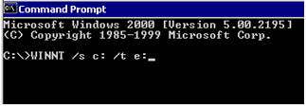
The WINNT.EXE and WINNT32.EXE programs, which set up Windows 2000, provide command line switches you can use to control the way the programs function. The syntax looks like this: WINNT [/s[:sourcepath]] [/t[:tempdrive]] [/u[:answer file]]. There are several other command switches, check your Windows 2000 install manual for details on other command switches.

Step 2: /s[:sourcepath]
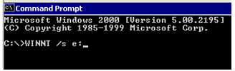
This is the location of Windows 2000 source files. This must be a full local or UNC pathname.

See also: http://www.mcmcse.com/win2k/guides/win2kpro.shtml#install

Information from http://ftq.itpoints.com/w2kp/

Windows 2000 Professional requires 2 GB with a minimum of 650MB free space on the boot partition. If your computer only has a 1GB hard disk with 1GB free space, it meets the minimum free space requirement but does not satisfy the hard disk requirement. You still cannot install Windows 2000 on your computer.

Boot Partition contains the Windows operating system files (i.e. \winnt) and its support files (i.e. \winnt\system32). To check which drive is your boot partition, you need to go to Command Prompt (From Start -> Run, and type CMD) and type echo %systemroot%

In the above example, your Windows operating system files are in C:\winnt and your boot partition is on C: drive.

For the Windows 2000 exams, besides boot partition, you also need to know the system partition.

The System Partition is the volume that has the hardware-specific files (i.e., NTLDR or OSLOADER.EXE, BOOT.INI, etc.) needed to load Windows NT. On x86 based computers, it must be a primary partition that has been marked active for startup purposes. The user should be careful not to change the drive letter of the system partition because many MS-DOS and Windows programs make reference to the C: drive. The system partition can be (but does not have to be) the same partition as the boot partition.

Some people might mix the System partition with Boot Partition because they thought the system partition contains system files. Please remember the following two sentences for the Windows 2000 exams.

1. The System Partition includes the files to boot Windows 2000.

2. The Boot Partition includes the System files.

A domain is a logical grouping of computers that share common security and user account information. A domain employs the user-level security model. As such, a user can use the same account to log on from any machine within the domain and get the same permission to access the resources within the domain. A domain model provides the following advantages:

1. Single user logon: Users access network resources according to the rights assigned by the corresponding domain. For example, after a user ww log on to computer1, he can access the authorized resources in computer1, as well as the authorized resources in other computers without extra login requests. Moreover, users can logon to the domain in any computer of the domain.

2. Centralized administration: A centralized view of the entire network from any workstation on the network provides the ability to track and manage information on users, groups, and resources in a distributed network.

3. Resource universal access: The administrator can grant users access to shared resources regardless of his location. Resource universal access makes 'Single User logon' possible.

A FQDN (fully qualified domain name) is a hierarchical name that provides a naming scheme for TCP/IP hosts. FQDNs are most commonly used in the Internet with a Domain Name System (DNS). FQDN consists of two parts: the domain name and the host name. For example, using the fictional domain, an FQDN for a web server could be www.yahoo.com. Note that the DNS name can actually be multi-part with each part of the name separated by a period (.). Microsoft suggests people use the domain part of the FQDN as the domain name in Windows 2000.

A workgroup model distributes the administration tasks. Each computer has its own database for user’s name and password. It is not saying that you cannot access the resource on other computers using workgroup model, but your login name could be different on another computer. Therefore, in a workgroup model, you assign passwords to each shared resource. The shared resource distinguishes people from the password provided. For example, if you shared a directory c:\ww on a computer, you assign "wwread" as the read-only password and "wwfull" for Full Access. Anyone knows the password "wwread" can only read the file on shared the directory, while those who knows the password "wwfull" can modify the files.

You can set up a Windows 2000 Professional computer join the domain or the workgroup.

Active Directory is the directory service that stores user accounts; computer accounts and other network objects and makes this information available to users and network administrators. Active Directory gives network users access to permitted resources anywhere on the network using a single logon process. It provides network administrators with an intuitive hierarchical view of the network and a single point of administration for all network objects.

Microsoft has another program called setup.exe (in the root directory of the Windows 2000 retail CD). If you are headache of figuring out whether your current OS is 16-bit or 32-bit, you can just run setup.exe for the installation and the setup.exe will detect the current OS and select the correct files for you.

If your computer supports the bootable CD-ROM nowadays, you can also boot the computer using the Windows 2000 CD and perform the Windows 2000 installation.

Windows 2000 supports FAT, FAT32 and NTFS three file systems. However, you might encounter other file systems such as HPFS on the Windows 2000 exam. Therefore, let's study the definitions of these file systems first:

FAT (File Allocation Table) is a table maintained by some operating systems such as MS-DOS, Windows 95, Windows NT, Windows 2000 as well as OS/2 to keep track of the status of various segments of disk space used for file storage. FAT is also called the FAT file system. FAT is the only file system that is supported by all the Microsoft operating systems. Because MS-DOS can only support FAT file system, if you want to dual boot MS-DOS with Windows 2000, you must implement the FAT file system. On a Windows 95 or DOS system, FAT is limited to 2 GB hard drives. Some people may have found that when they purchased a 6GB hard disk, they had to partition the disk to three 2GB disks using the fdisk command and ended up with (c:, d: and e: three disk drives in their system. This is because of he 2GB limitation of the FAT file system.

A dual boot is a configuration that you have multiple operating systems installed on your computer. You can choose which operating systems you want to start each time you reboot the computer.

FAT32 is the 32-bit version of FAT. Although FAT is a 16-bit file system, we usually don’t call FAT FAT16. FAT32 was available on Windows 95 since late 1996 and it increased the drive limitation to 2TB. FAT32 is supported on Windows 95, Windows 98 and Windows 2000 while not MS-DOS and Windows NT. Therefore, if you want to dual boot Windows 2000 with Windows 98, you can either use FAT or FAT32 file system. However, if you want to dual boot Windows 2000 with MS-DOS, you can only use FAT.

To check what your current file system is, you can open Windows Explorer and right clicks the C: drive, click properties to see if your system is FAT, FAT32 or NTFS.

Because FAT file system does not support partitions larger than 2 GB, if you attempt to format a partition larger than 2 GB with FAT in Windows 2000 Setup automatically formats the partition with FAT32.

NTFS (NT File System) is an advanced file system that was designed for use specifically within the Windows NT operating system. NTFS supports file system recovery, extremely large storage media, long filenames, and various features for the POSIX subsystem. It also supports object-oriented applications by treating all files as objects with user-defined and system-defined attributes.

For the Windows 2000 exam, you need to know three things about the NTFS:

1. NTFS only works on the Windows NT or Windows 2000 platform
2. NTFS has more security features than FAT
3. You can run most of the MS-DOS and Windows application on NTFS

In fact, when you logon to a Windows 2000 computer locally, anybody can access the folders on the FAT file system. There is no way to prevent anyone from accessing these FAT folders if he can login locally. That’s the reason why Microsoft suggests people use NTFS on Windows 2000. For the drives using NTFS, user-level security can be implemented on different folders and you can prevent users from accessing local system files.

For small directories, the FAT file system may be faster to get to the file, because:

- The FAT directory structure is simpler.
- The FAT directory size is smaller for an equal number of files.
- FAT doesn’t have to check permissions for an individual file or whether a specific user has access to the file or directory.

The NTFS file system uses a binary tree structure for all directories. This structure minimizes the number of disk accesses required to find a file, which means that the NTFS file system should be faster for larger directories.

The FAT file system is best used on smaller volumes than approximately 400 - 500 MB. That’s because the FAT file system starts out with very little overhead. However, the FAT file system is very inefficient for the volumes large that 1 Gigabyte (GB). Because Windows 2000 requires a 2GB hard disk, you’d better always implement NTFS instead of FAT except that you need to dual boot the system with Windows 95/98 and MS-DOS.

HPFS (High Performance File System) from IBM is the file system introduced with OS/2 that handles large disks (2TB volumes; 2GB files) and long file names (256 bytes). It coexists with the existing FAT system. Please note that HPFS has nothing to do with HP Corporation but is an IBM product.

As far as Microsoft Products go HPFS is compatible only with Windows NT 3.5x. To reduce the system overhead, Windows NT 4.0 and Windows 2000 no longer support HPFS. It is easy to understand that when not many people use Microsoft’s products, Microsoft needs to support as many file systems as possible. After Microsoft acquires the market share, Microsoft is focusing more on its operating system’s performance. Supporting more file systems will definitely increase the system’s overhead.

The following table lists the supported file system on MS-DOS, Windows 3.1, Windows 95/98, Windows NT as well as Windows 2000.
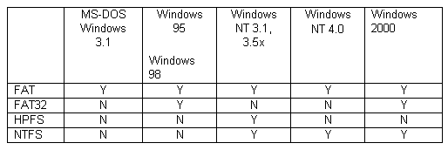

To install service pack after installing Windows 2000, you can run update.exe to replace the existing Windows 2000 files with the appropriate files from the service pack.

Lab Exercise 6 -- Installing Windows 2000

Windows 2000 Post-Installation Customization Tips
See http://www.pcworld.com/features/article/0,aid,104690,00.asp

Using a Windows 2000 Network
Read the following web pages:
http://userwww.sfsu.edu/~lennyb/edsite/chap25_1.htm
http://userwww.sfsu.edu/~lennyb/edsite/chap25_2.htm
http://www.itknowledge.com/reference/archive/0789714884/ch36/ch36.htm

Understanding Networks
What is a network and why create one? A network consists of the components necessary for two or more computers to communicate. The advantages of networking include:
- Monetary savings. Sharing hardware results in saving money. The most common type of hardware that is shared is a printer. Networking enables you to purchase one color printer and give everyone the ability to print to it.
- Fast access to information. You can access the needed information directly from your PC which eliminates the need for running around with a floppy disk looking for that particular memo or letter.
- Easier information management. By agreeing to store certain types of information in one location, you can always find what you need. It also allows for routine backup of important documents and data.
- Shared access to information. Customer information can be stored in one database so that all users can access it.
- Better communication. The use of email and group scheduling applications increases productivity.
- Improved efficiency. Networking results in improved access to a large variety of information, which means projects are completed in shorter periods of time.

A network consists of two types of components: hardware and software. The hardware components consist of various pieces of equipment that connect the computers. At a minimum, the hardware necessary to allow computers to communicate includes cables and adapter cards. Windows 98 integrates well no matter what the topology of your network. The software required to communicate across a network includes the network operating system, a network client, and a protocol.
Windows 2000 can function as a networking operating system as well as a desktop operating system. A network client allows your computer to communicate with another computer based on the type of network operating system it is using. A protocol can be thought of as the language that is spoken across your network. If two computers use different protocols, they cannot communicate.

How Peer-to-Peer Networks Work
Networks can be organized in two ways: peer-to-peer and server-based. In a peer-to-peer network, each computer acts as both a server and a client. All information is stored on each individual computer. When a computer is playing the server role, it provides access to files contained on its local hard drive and peripherals attached to it (such as printers, FAX modems, scanners, and CD-ROM drives).

Each computer can share its resources without the need for centralized administration of these resources. Each user in a peer-to-peer network is a network administrator. This alleviates the need for one person to be responsible for various network administrative tasks.

Windows 2000's built-in networking capabilities make it an excellent option for implementing a peer-to-peer network. As an operating system, it contains all the elements you need to allow access to local resources or to access resources located on other computers in the network. This native networking ability enables the easy sharing of local resources and access to remote resources.

Windows 2000 has a point and click interface that permits you to browse the network to locate and access available resources. The same easy-to-use interface makes the sharing of resources extremely easy for the user. This interface alleviates the need for the user to be technically adept at network administration, while still providing access to network resources.

How Server-Based Networks Work
You can change a peer-to-peer network to a server-based network by adding a computer running the Windows NT Server operating system or a NetWare server. The basic requirements for a server-based network are:
- A centralized user database, which is used to verify that the user requesting access is authorized for the level of access requested.
- Centralized repository of information. Files can be stored on one or more file servers and can be accessed by all the users on the network. This allows for easier access to saved documents. It also makes creating backups easier because only one computer needs to be backed up, rather than backing up each individual computer in your network.
- Centralized control of resources allows the administrator to designate which users have access to stored documents and shared peripherals. It also allows for easier configuration of these resources.
In a server-based network, the burden of controlling network administrative tasks is moved from the individual user to one or more persons who are more technically proficient in network administration. This central administrative role allows for more efficient management of the network.

Windows 2000's client ability allows it to work very well in this type of environment by providing the software necessary for user authentication, which then allows access to network resources.

Creating a Workgroup
A workgroup is an organizational unit. It is a loose association of computers wherein each computer tracks and controls access to local resources. These resources may be folders located on the local hard drive or hardware devices attached directly to the computer (such as a printer). Each individual computer in the workgroup controls how access to these resources occurs.

If your network is small--fewer than 10 computers--a workgroup is an easy way to configure your network and provide access to various resources. It does not require a single individual to be designated as the administrator. Rather, each user is the administrator for his own computer.

The disadvantages associated with a workgroup are related to its advantages. Because each user is his own administrator, there is no centralized control of users or resources. As your network grows, the large number of users can result in a disorganized network. Because there is no centralized location for shared documents and applications, it can become difficult for a user to locate needed information. This can result in lost productivity or the occurrence of duplicate versions of the same document.
Printing is one of the most common tasks performed on a network, and shared printing can lead to problems. Because the computer that is attached to the printer is acting as a print server, the additional load can cause degradation in performance. This can be a significant problem affecting the user working on that computer.

See also: http://www.winsupersite.com/showcase/ty_net_intro.asp

File sharing is enabled through the File and Print Sharing button on the properties sheet for the My Network Places. You can elect to share files, allow others to print to your printer, or both.

Configuring Windows 2000 for Resource Sharing
Before any type of sharing is allowed on Windows 2000, you must first configure Windows to allow sharing and to share other resources.
- Open the Network and Dial-Up properties from the Control Panel or right-click My Network Places. Right-click the Local Area Network icon and choose Properties.
- Verify whether an entry appears for File and Print Sharing for Microsoft Networks. If you see the File and Print Sharing for Microsoft Networks service installed with a checkbox, your computer is configured for file and printer sharing.
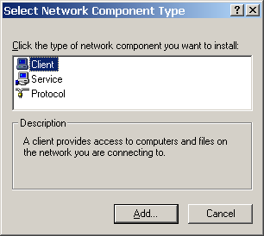
- If it's not there, choose Install. Click on Service in the next dialog box, then choose File and Print Sharing for Microsoft Networks and Click OK.
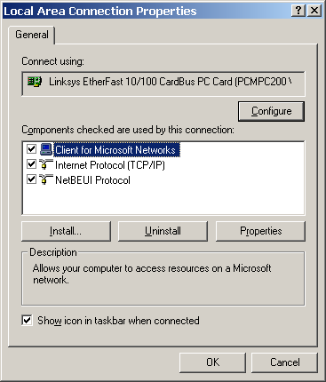
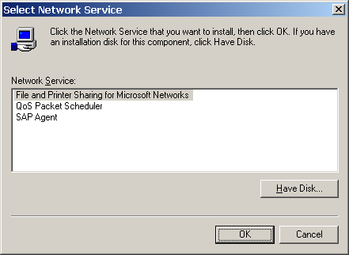

- After you checkmark the file sharing options and click close, the sharing feature will be installed. You can check this by opening My Network Places. When File Sharing is installed, an icon for your computer will appear in the default listing for your workgroup.

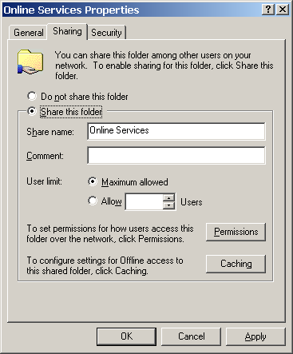
To share a folder, right-click on it in Windows Explorer and select Properties. On the Sharing tab, select Share This Folder. Each shared folder must have a name to identify it. A suggested name will be displayed, but you can enter whatever name you want to use. The name that you enter here will be displayed to any user browsing your computer across the network.

Exercise 7 in Labs handout -- File and Printer Sharing

Setting up a Windows 9.x/2000 Network

What you need for a dedicated network connection:

Client (for Microsoft Networks or Novell Netware)
Network Adapter (interface card)
At least one network protocol (TCP/IP, IPX/SPX, or NETBEUI) linked to NIC

Optional components:

For Dial-Up network connection through a modem:
Dial-Up Adapter
Network protocol linked to Dial-Up Adapter
(TCP/IP linked to Dial Up Adapter is required for Internet connection)

Microsoft Family Login

Infrared Serial Port

Fast Infrared Protocol
Microsoft Virtual Private Networking Adapter
Additional transport protocols
File and Printer Sharing (for Microsoft Networks or Novell Netware)
Internet Connection Sharing (Windows 98 SE, only)

TCP/IP Protocol Setup

IP address for this computer (auto-assigned or specified)
Gateway

Identification

Specify computer name (which is also NETBIOS name for Windows NT)
Specify Workgroup

Using Plug and Play for Automatic Network Setup
The goal of Plug and Play is computer devices that configure themselves without manual user intervention. Generally, to install an internal Plug and Play device, all you need to do is turn off the machine, install the board, and turn the machine back on.
Windows 98 should then automatically detect the device, install the appropriate device drivers and supporting files, and configure the hardware resources, such as the following:
- Interrupt Request Lines (IRQs)--Hardware lines over which peripherals send requests for service to the CPU.
- Input/Output Ports (I/Os)--Hardware paths from the hardware bus to the CPU used for communication by peripheral devices.
- Direct Memory Access channels (DMAs)--Used by "intelligent" peripherals to directly access system memory without going through the CPU.
To see how your computer's hardware resources are currently allocated, follow these steps:
1. In the Control Panel, open the System icon.
2. Click the Device Manager tab.
3. Highlight Computer at the top of the device tree.
4. Click Properties.

Installing and Configuring a Network Adapter
The network adapter is your critical link to the network. It is the physical connection of your computer to the actual network cabling.
As already described in the section on Plug and Play devices, after the system is powered back up, Windows 98 will detect the new hardware and the protocols running on the network wire, install the NDIS drivers, and configure a Plug and Play network adapter automatically.

If you install a legacy (a non-Plug and Play) adapter, there are some additional steps you need to take to get it to work with your Windows 98 or Windows 2000 client. First of all, you will want to make a note of what system resources are available to be assigned to your card. To get a resource report, do the following:
1. In the Control Panel, click the System icon.
2. Click the Device Manager button on the Hardware tab.
3. From the View menu, select Resources By Type and Expand the Interrupt Request section.
NOTE If your adapter is the ISA bus type, it will need exclusive use of an IRQ assignment. If it is a PCI bus type, it probably will be able to dynamically share an assignment with another device already installed in the system because most recent PCI adapters are Plug and Play devices.

Configure your legacy non-PnP adapter by either setting the appropriate hard wired configuration jumpers or dip switches, or use a disk- or CD-ROM-based software configuration utility. Then install the adapter in an available expansion slot.
To configure a legacy adapter with a vendor supplied utility, boot Windows into a Safe Mode Command Prompt by holding down the Ctrl key during boot up and choosing that option from the Startup menu. After you have configured the card through software, power down the computer and restart it, and then wait for Windows 98 to come up and hopefully detect the addition of the new hardware.

Choosing a Protocol and Adjusting Bindings

To install a protocol or protocols on your network node, follow these steps:
- In the Control Panel, open the Network and Dialup Settings folder.
- Select the Local Area Connection icon for your network card, right click and open its Properties.
- Click the Install button, select Protocol, and then click the Add button once more.
and choose the protocol you want to install. Click OK.
- When you return to the General tab in the Local Area Connection properties box, you can choose which protocols will be active for this connection.
- To adjust the protocol bindings, choose Advanced Settings from the Advanced menu in the Network and Dialup Settings folder. To deselect a binding, remove the checkmark next to it.
See Lab Exercise 8

How Do I Share the Internet With Other PCs?
See http://www.pcworld.com/howto/article/0,aid,61687,pg,9,00.asp

Troubleshooting Guides

See http://www.itpoints.com/ftq/w2kp/6.htm
See also: http://www.a1computers.net/START.HTM

Symptom | Possible Diagnosis | Possible Cure
Blank Screen, CPU light off, Monitor light off | Not turned on, no power to outlets, bad power strip | Turn on/off monitor and CPU. Unplug the power cords and plug them back in securely. Turn off the power strip and turn it back on. Test the power strip with another device to make sure that power is going to computer.
Blank Screen, CPU light off, Monitor light on | Not plugged in, power off, bad power strip, unseated/bad video card/ io device, CPU Dead | Turn on/off CPU. Unplug the power cords and plug them back in securely. Turn off the power strip and turn it back on. Test the power strip with another device to make sure that power is going to compute.
Blank Screen, CPU light on , Monitor light on | Contrast and or Brightness turned down/up all the way, Bad Monitor/CPU | Unplug the monitor cable from the CPU and plug it back in securely. Adjust the contrast and brightness buttons in front of the monitor. Adjust each so that they are about half-way so that they can be seen.
Keyboard Error | Keyboard unplugged | Unplug and plug it back in securely, make sure keys are not stuck.
Drive Failure Error | Hard Drive Failure, Incorrect CMOS Settings | Turn the power or restart button
Non-System Disk Error | Hard Drive Failure, No System Files. Floppy in Drive. | Remove Floppy from drive and restart computer.
Mouse not functioning properly | Mouse unplugged, mouse dirty, missing mouse ball | Unplug mouse and plug back in securely, Replace missing mouse ball. Remove mouse ball cover, clean mouse ball and rollers on inside with a damp cloth.

 | SCANDISK ERROR | This occurs when a Windows 95 Machine has not shut down correctly | Run scandisk by pressing any key. To navigate through the program, use your right and /left arrow keys, to select press enter. When prompted you will want to make the following selections:  "Delete It", "Fix-It", "Skip Undo"
 | Error: Username you typed is invalid | The username is incorrect | Check spelling. The username is your 1st initial last name, all lowercase, one word (i.e. jsmith)
 | Error: You are not logged on to the local area network | The username and password are missing | Enter username and password. See Login/Username Tutorial
 | Error: Username cannot be found | Username is incorrect | Check spelling. The username is your 1st initial last name, all lowercase, one word (i.e. jsmith)
 | Error: You must specify a domain to log on to | The domain name is missing or incorrect | Enter the appropriate domain for your school. See Login/Username Tutorial for a listing of domains
 | Error: No domain server was available to validate your password | The domain name that was entered was incorrect | Enter the appropriate domain for your school. See Login/Username Tutorial for a listing of domains. If you do not login correctly you will not have access to the network.
 | Programs are missing | Did not login correctly. Network cable is unplugged. Network card is not seated properly. | Re-logon. Shut Down using "Close all programs and logon as a different user". Turn the computer power on/off. See Login/Username Tutorial. Unplug and plug in the network cable. Check for lights where the cable connects
 | Error: The set of folders could not be opened. You do not have permission to log on | Trying to access someone else's Email box. Did not log on using the correct domain. Your profile has not been added to the inbox. | See Email Tutorial
 | No Internet access | Bad Network card, Network card is unseated, Network cable is not plugged in, Proxy Server option has been turned off, Did not login properly, | Relogin using Login/Username Tutorial. Unplug network cable and replug it in firmly (look for lights on Network card you plug the cable into), See Internet Tutorial

see http://www.esctechsite.com/build/common.html

1 | Read your manuals thoroughly.
2 | Before you touch any of the parts, ground yourself (i.e. by touching the metal case or wear a wrist strap).
3 | Make sure all of the computer components are away from plastic wrap, packing material, and in a static free area. Also, before you touch your system always make sure the power is off.
4 | Do not add or remove components when the power supply is plugged into the wall. When ATX Power supplies are plugged into the wall and into the motherboard, a 5 Volt supply is being provided to the board.
5 | Now that you have your new computer parts then you will want to make sure everything works. Do not rush and plug everything in at once. Assemble a 'barebone' configuration and then test it before building a much more complex system.

a | Jumpers are not set correctly for the processor.
b | Memory is not seated properly
c | The wrong kind of memory is used.  - PC100 memory for opearting at 100 MHz.  - ECC memory should not be used on Super 7 motherboard.  - Registered must be used with registered.
d | AGP video card is not seated properly.
e | Video card requires an IRQ.
f | PCI and AGP are using the same IRQ. Check with your supplier or manufacturer to make sure that the PCI card can share IRQs.
g | Motherboard is mounted to a case in a fashion which causes a problem.
h | I/O shield that comes with the case does not work with your motherboard. Some motherboard manufacturers do supply a generic I/O shield.
i | Installing the wrong type of motherboard.  - Incorrect form factor  - The size of the motherboard is too large  - The shape of the motherboard doesn't allow mounting into the case because the processor will hit the power supply or the memory will hit a drive bay.
j | Cables are backwards or damaged.
k | BIOS isn't set to the defaults
l | Power supply doesn't have a Vsb of at least 0.8 A.
m | Disconnected or unplugged parts while the power is available.
n | Putting the cover onto the PC causes the machine to not POST. Check the seating of all cards in the expansion slots.
o | BIOS was flashed and the board is dead. Try recovery procedures, hot swap, or BIOS replacement.
p | Hard drive is not recognized. Check the cable and BIOS settings.
q | IRQ conflict
r | Video drivers are out of date of date.

Input/Output

Overview of standard IRQs and Port Addresses

IRQ 2 (Keyboard/System)
IRQ 3 (Port 2F8) COM2
IRQ 4 (Port 3F8) COM1

IRQ 5 -- open for sound card, network card, or second parallel port (port addresses: 3B0, 278: LPT2)
IRQ6 -- Floppy disk controller (port 3F0)
IRQ7 -- usually printer port (port 378) LPT1:
IRQ8 -- System CMOS/Real Time Clock
--------------------------------------------
IRQ 9 (peripheral or reserved)
IRQ 10 --(peripheral or reserved)
IRQ 11 (peripheral or reserved)
-------------------------------------------
network cards, sound cards, scsi cards, usb controller, PC Card controller, video accelerator

IRQ 12 -- PS/2 or Bus mouse/touchpad
IRQ 13 -- Numeric data processor (internal)
IRQ 14 -- IDE hard disk controller, first port (1F0)
IRQ 15 -- IDE hard disk controller, second port (170)

Information about actual allocation of these resources can be determined
- through CMOS settings
- through DOS diagnostic utilities
- through Windows 2000 Device Manager
- through Windows 2000 diagnostic utilities

Supplement: Preparing a new hard disk for Windows 95/98 installation

If you have a new hard disk purchased separately from your computer, it must be partitioned before you can install Windows 95/98. To partition a hard disk you need

a) a bootable version of the Windows 98 Second Edition CD-ROM or
b) a floppy boot disk formatted with some version of the MS-DOS operating system.

If you have a copy of Windows 98 Second Edition on a bootable CD and a computer that supports booting from the CD-ROM drive, you can just insert this CD, turn on the computer, and it will run, giving you the options of 1) accessing a DOS command prompt and installing Windows 98 on a formatted hard drive. 2) formatting and partitioning a new hard drive from scratch, automatically installing the Windows 98 operating system.
Generally, you won't want a version dated previously to 8/24/1996 when Microsoft added support for large FAT32 disk partitions to Windows 95. (Before this point, the largest size permissable for a DOS/Windows disk partition was 2 Gigabytes.)

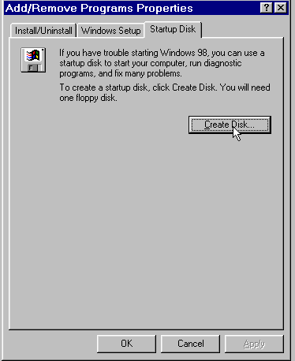
If you have Windows 95 (or better than that, Windows 98) installed on another computer, the easiest way to obtain a system boot disk is to create one from the version of Windows installed on the other computer. (Open the Control Panel, choose Add/Remove Programs, go to the Startup Disk tab and click the Create Disk button.)

If you want to install Windows 95/98 on a hard disk that already contains a bootable c-drive (or reinstall over an existing version), then boot the computer from your floppy Windows Startup Disk, (if you created the startup disk in Windows 98, choose "Load CD-ROM support, when prompted). Then insert your Windows CD, log on to your CD-ROM drive and enter the command SETUP. If you are using a "For a New PC copy of Windows 98, then format the hard disk first:

FORMAT C:
Using FDISK to partition a hard disk

For a new hard disk, or to create brand new partitions on an existing hard disk, you must use the DOS FDISK utility. After booting to a DOS prompt (A:\> or C:\> with an emergency startup disk.

- Enter FDISK at the command prompt.
- If this version of DOS supports FAT32, you will see an initial screen prompt asking whether to enable large disk support. If you want to install Windows on a FAT16 partition, (compatible with Windows NT 4.0 and some other operating systems) answer No. If you want to install Windows on a FAT32 partition (with a single c-drive as large as your hard disk, better Windows 98 performance, but no ability to dual-boot Windows NT 4), answer Yes.

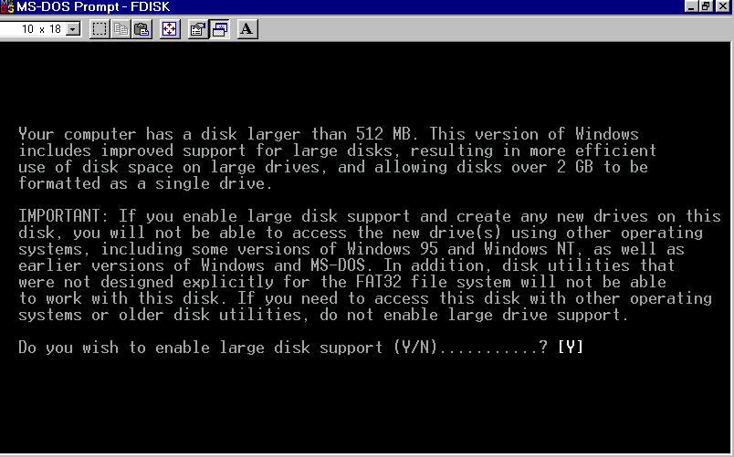
- On the next screen, to create a new bootable c-drive on your computer, choose option 1, Create DOS Partition or Logical Drive. then choose option 1 again on the next screen, Create Primary DOS partition
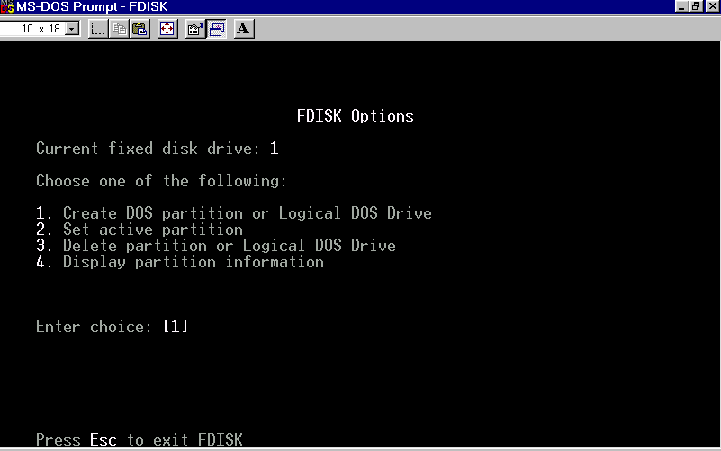

- If Windows 98 will be the only operating system on the disk, allow FDISK to create a c-drive on the next screen that uses all available space on the drive. If you intend to install Windows NT or another operating system on the disk later, then limit the amount of space reserved for Drive C. (If you have a 6.4GB disk, for instance, and want to dual-boot Windows NT you might create 2GB partition for drive C and allow Windows NT to use the rest of the drive, later on, to install itself. Remember that drive C must be FAT16 rather than FAT32 for you to do this.)

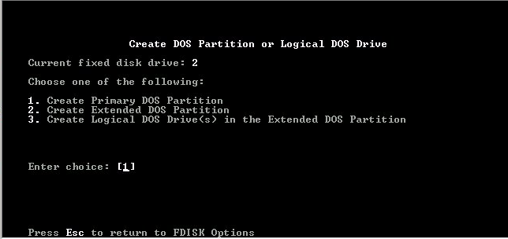
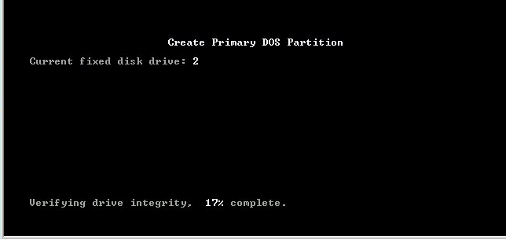
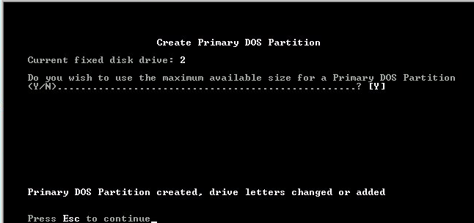

- FDISK will prepare the hard drive and prompt you to reboot the computer. Before quitting the program, press Esc until you're back at the first Options menu. Choose Option 2, Set active partition and then, on the next screen, enter 1 to activate the C-drive you've created.
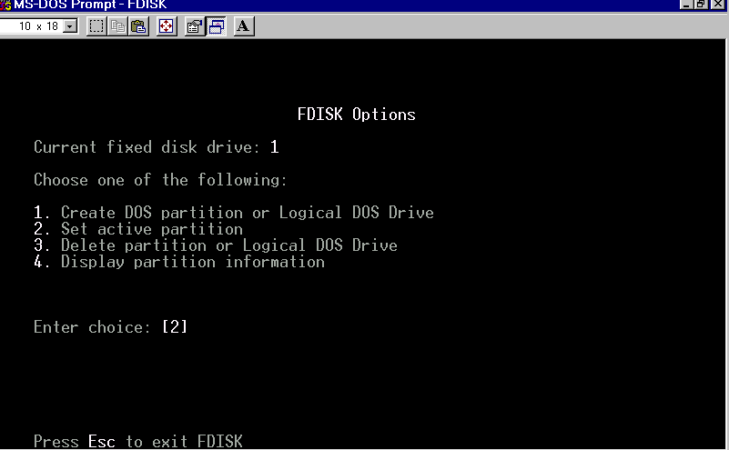
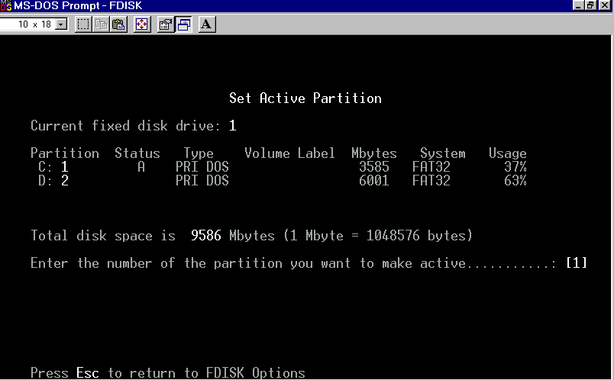

- Now exit FDISK and reboot the computer from your Win98 CD or floppy startup disk. (If you boot from the Windows CD, choose the option to boot to a command prompt. From either CD or floppy, choose the option to load CD-ROM support.
- When the computer reboots to a command prompt, issue the following command:
FORMAT C: /S.

Your C-drive is now bootable and ready for the Windows installation. Log onto the drive letter of your CD-ROM and enter the command SETUP.

