Day 1

Lab 1:

External identification and startup
Starting Windows, Starting DOS

System Unit:

Identify
power switch
power-on LED
hard drive LED
system lock (if present)
floppy drive (A:)
CD-ROM drive (open and close)

Briefly examine the back of computer:
observe ports that connect to monitor, keyboard, and network

Start the computer:
Watch LEDs for floppy disk, CD-ROM and hard disk

observe boot process as monitor lights up and Windows appears

Pausing the screen display before the operating system starts

Press Pause key before Starting Windows message appears

On many PCs, the monitor will display status information about the hardware configuration before the computer reads the disk drive and loads the operating system. To see this information, press the Pause key before the Windows NT boot menu appears on the screen. The display will freeze. To continue the boot process, press the spacebar.

Troubleshooting tips:

Restart the computer and re-observe the boot process. Watch the front panel lights on the computer and the display on the monitor.

If the front panel LEDs don't light up, and you don't hear the system fan, the power supply for the computer may be bad, or the computer may not be plugged in.

If the monitor doesn't light up, it may be switched off, or the cable may not be connected.
(There may also be a problem with one of the peripheral cards inserted in the PC's motherboard. We'll learn more about this in the second session.)

The floppy and CD-ROM drives should light up briefly. If they don't, there may be a loose internal
cable.

All three keyboard LEDs should light up briefly before the computer loads the operating system. If they don't, the keyboard cable may not be connected, or the keyboard may have a hardware defect.

Feel the back of the computer and see how hot it is. If the computer is really hot, the fan built into the power supply may be insufficient to cool the system, and hardware problems may develop. (There is often a second fan attached to the system's CPU. We'll see this in the second session.)

Monitor controls
Switch monitor off and back on
While in Windows, identify and use the brightness and contrast controls
Identify the fine adjustment controls shrink/expand and move picture horizontally and vertically

Shut down Windows

Starting Windows 2000

- Turn power on. Choose Windows 2000 if a boot options screen appears.
- Login: enter username and password
- Inspect Control Panel options:
Set date/time, inspect System properties, inspect Users and Passwords, Inspect Administrative Tools.
- Desktop options: Show/hide all system files
- What's new Check out tutorial at http://www.mcmcse.com/win2k/guides/features.shtml
- Backup: Check out tutorial at http://www.mcmcse.com/win2k/guides/backup.shtml

Using a command-line session:

Open an MS-DOS command-line session.

- Notice that you are at the C-prompt (C:\WINDOWS>_ ) This is the basic interface for
- The MS DOS operating system, called the command line. The command-line is used to run small text-interface applications in MS-DOS, Windows, and most variants of Linux and Unix.
- You may enter a variety of text commands at the C-prompt. After typing the command, press ENTER to execute the command.
- Example, type the DIR command and observe the results. Compare with the standard file listing in Windows Explorer under Windows 2000. (Type DIR /P to display file listings one screen at a time. Type DIR /? to see a list of command-line options. Type DIR /X to display short filenames.)

Get to know the keyboard by using the Command Line

Type in the word "EDIT" at the command prompt and press the ENTER key.

What do you see?

Alpha-numeric keys, Shift key, Capslock, Enter, Backspace
Type some text in the MS DOS Edit window that you've opened and experiment
with the effects of toggling the Shift and Capslock key on and off.

Insert key toggles text entry between "bump over" and "overwrite" modes.

Function keys: F1 through F12
invoke special commands built into the software program. These key can launch different
tasks in different programs
F1 is usually HELP
F3 is SEARCH in the DOS EDIT program.

Enhanced Function keys: CTRL, ALT, SHIFT
By holding down one of these keys at the same time you press a function key, you triple the number
of available function commands.

Alt + F opens the pulldown file menu.
Try this combination, choose the Open command and enter the following in the filename field:
C:\WINDOWS\TIPS.TXT

Ctrl+Home usually moves the cursor to the start of a document
Ctrl+End usually moves the cursor to the end of a document.

Navigation keys: Four arrows, PgUp, PgDn, Home, End
PgUp and PgDn usually move the text up or down a full screen
Notice that the cursor keys do not delete text. To delete text, you use
the BACKSPACE key (deletes character to the left of cursor) or the DEL key
(deletes character to the right of cursor)

Numlock and Keypad
The Numlock key toggles the auxilliary keypad on the right of the keyboard back and forth between being a numerical data entry pad and serving as an extra set of navigation keys.

Extra PC Keys:

PrtScrn captures the current output on the screen and sends it to a printer (under DOS) or to the
Windows Clipboard (under Windows)

Scroll Lock changes the way text scrolls in some applications

Windows keys: on some keyboards, under Windows, these shortcut keys automatically open the Windows Start Menu or simulate a right mouse-click.

Fn key: On notebook computers with small keyboards, the Fn key works like the Ctrl key, activating special programmed functions built into an ordinary alphanumeric key on the keyboard. For instance: Fn+ a function key (F1-F12) may display battery status or toggle the display between an internal screen and an external monitor.

Keyboard Status LEDS: Capslock, Numlock, and Scroll Lock LEDs report the status of these three keys.

Close the MS DOS Edit program. (Hint, look for the Exit command on the File Menu, by pressing ALT +F).

Close the command-line session.

Questions:

- How can you gain information about the model of your computer, installed memory, and installed hardware before the Windows operating system boots?

- What is a quick way to see whether the computer is responding to the keyboard?

- If the computer has started to boot Windows but appears to be frozen before the desktop appears, how might you tell whether the operating system is still loading?

- How would you find out what kind of video card is installed in your computer? What kind of video card is installed?

- How can you determine the number, size, and type of the partitions installed under Windows 2000? What size and type partitions are installed on your computer?

- Why does Windows 2000 hide the names and extensions of some of the files on the computer? How can you view these files if you need to troubleshoot?

Get to Know the Disk Drives:

The floppy drive in the system is generally identified as Drive A.
The hard disk in the system is generally identified as Drive C (there may be additional D and E partitions)
The CD-ROM drive in the system is usually assigned the first available drive letter after the hard disk partitions used by the system. (It may be Drive D, E or F.)

Insert and remove a floppy disk.
Open and close the CD-ROM drive.

See also:
DAY 2

Lab 2: Identifying Internal PC components

Proper procedures for working on computer:
Tools
Place to store screws
Disconnect power cables
Ground yourself before opening computer

Review troubleshooting procedures.

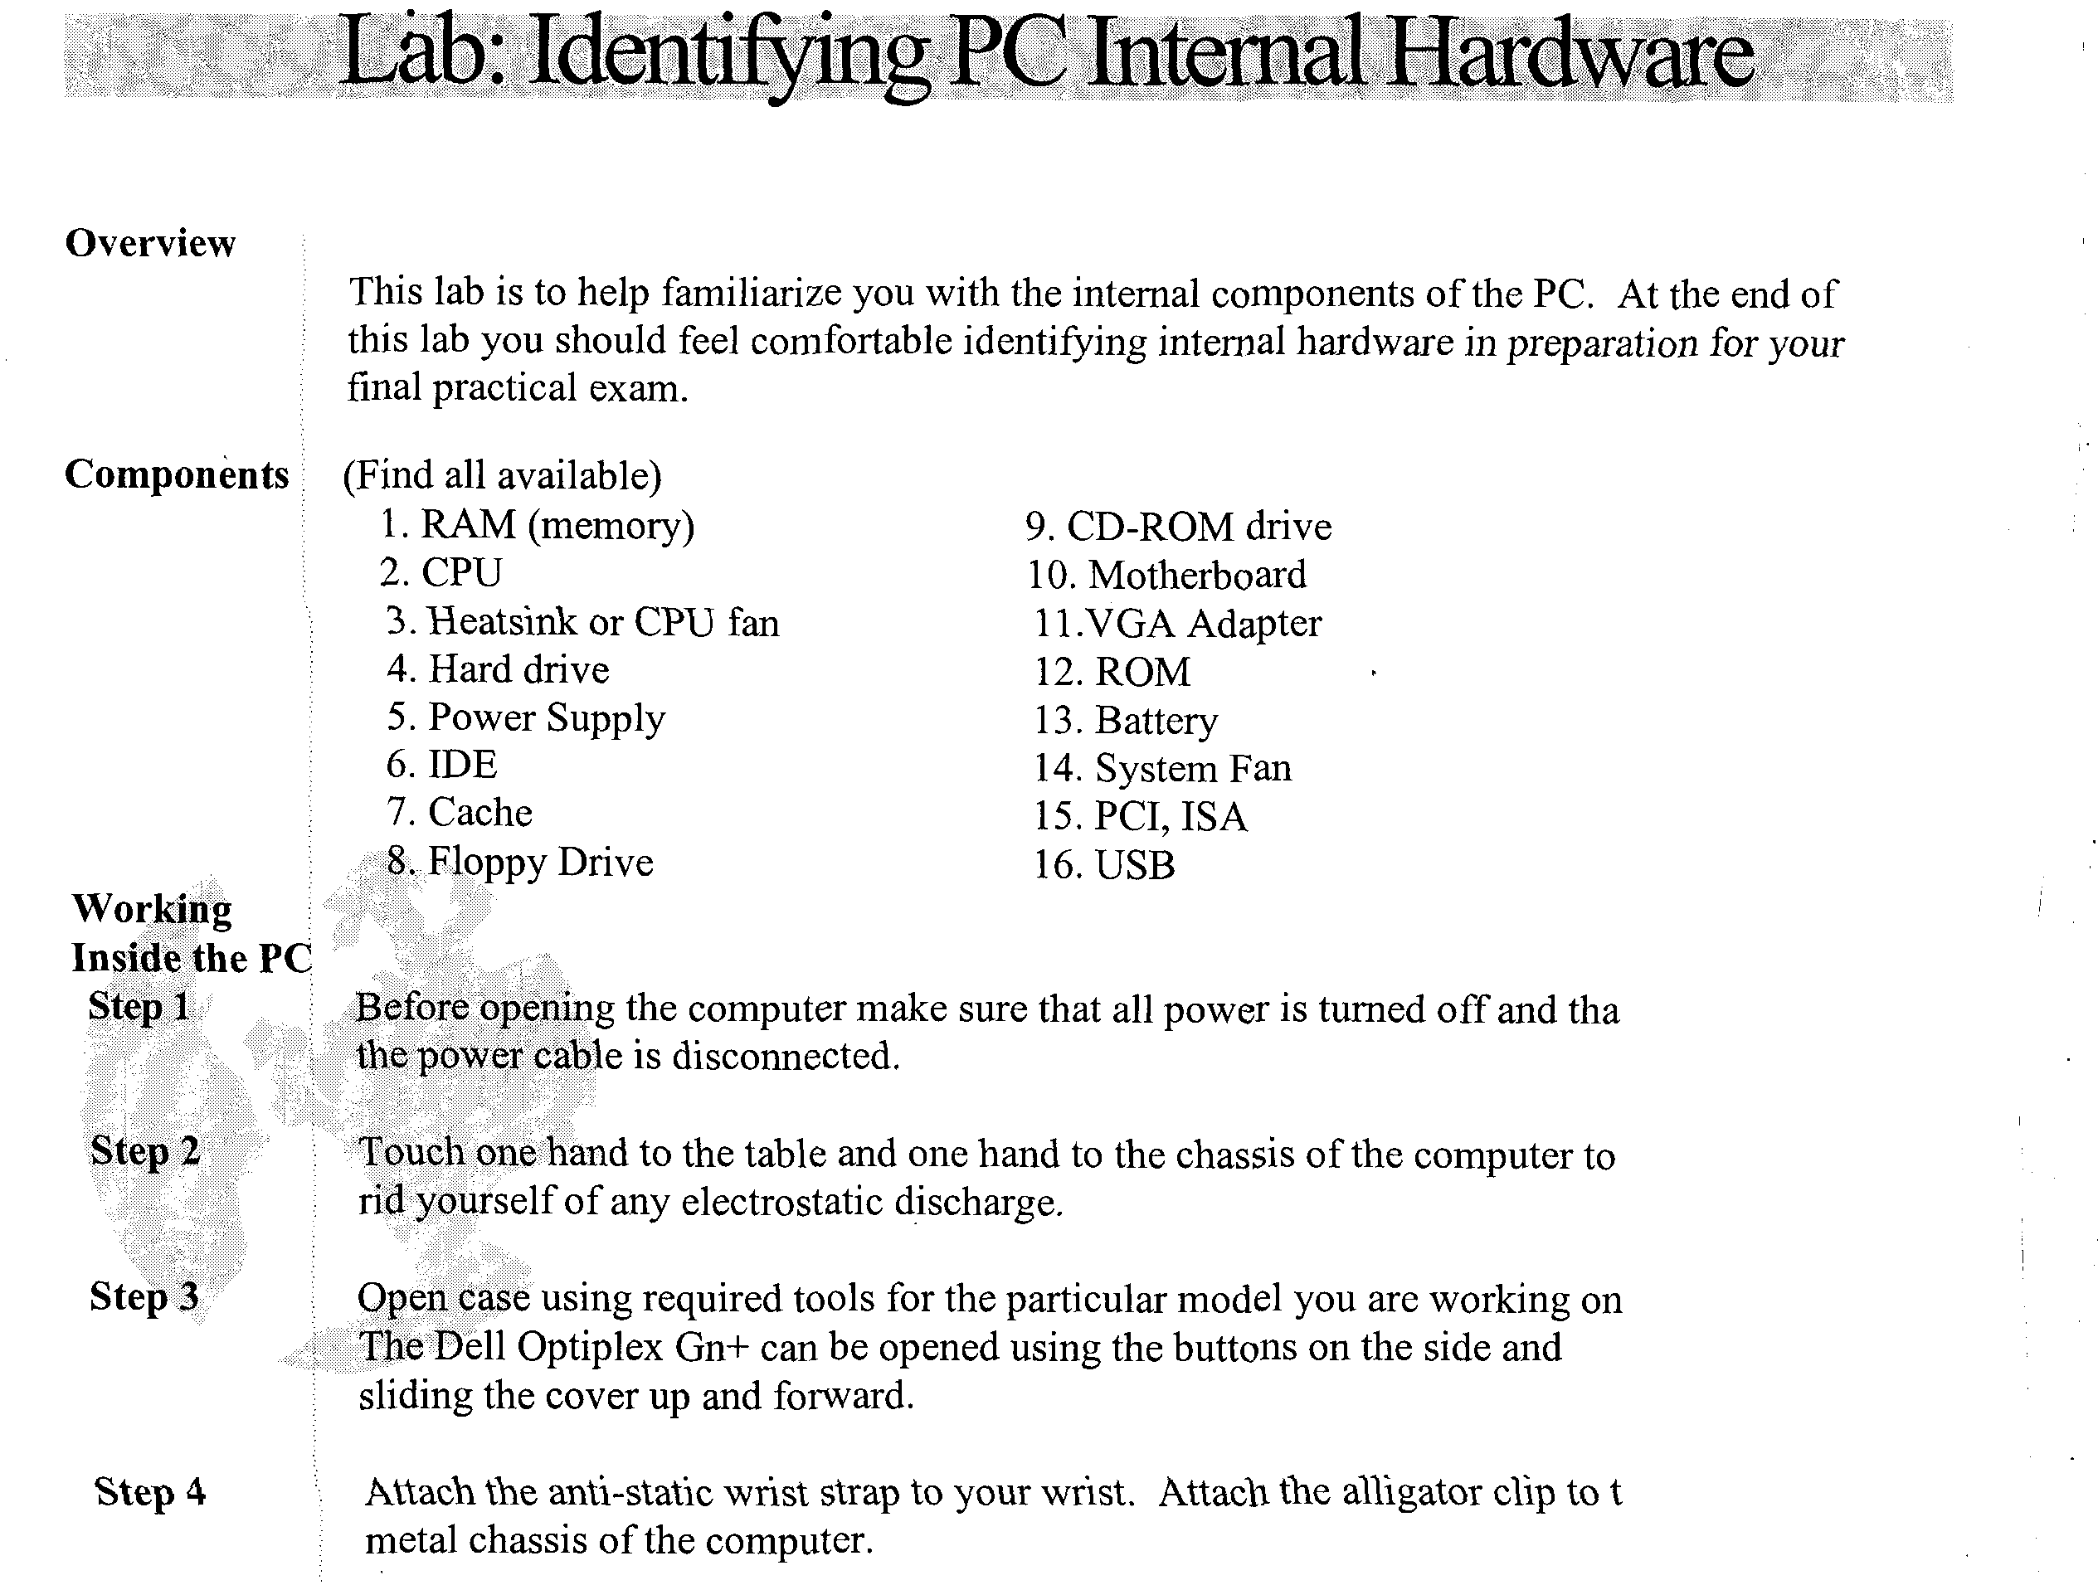

Hardware identification matching (match the number of each component in the list below).
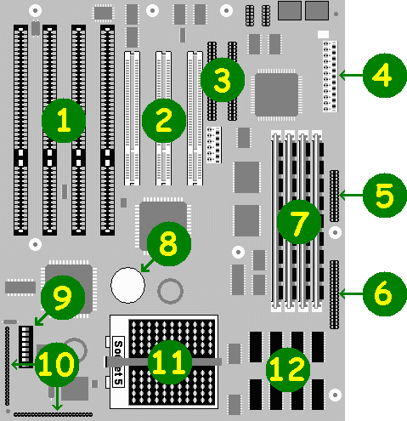
- Parallel port connector _____
- Floppy disk controller connector. _____
- ISA (Industry Standard Architecture slots _____.
- PCI (Peripheral Connect Interface) slots _____
- Hard drive controller connectors 1 and 2 _____
- Power connector. to power supply _____
- Lithium backup battery for the CMOS. _____
- Pentium processor in its socket _____
- SIMM (Single In-line Memory Module) sockets for adding memory. _____
- 256K cache (those systems with an external cache only) _____

- Front panel connectors for the internal speaker, keyboard and hard drive
lights, +12v fan, _____
- Configuration jumper block for changing the ISA bus clock, clearing a
CMOS password, resetting the CMOS to the default settings, etc. etc. _____

Symbolic - Pictorial equivalence

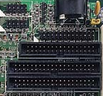
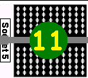
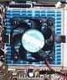
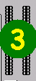
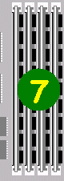
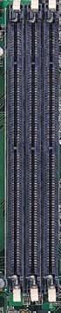
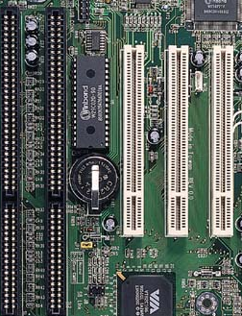

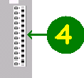
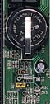

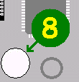
Lab 3: Bits, Bytes, Kilobytes – hexadecimal conversion

Unit conversions
?_______ bits = 1 byte
?_______ bytes =1 word (for Intel PCs)
?_______ bytes =1 kilobyte
?_______ kilobytes= 1 megabyte
?_______ megabytes = 1 gigabyte

You can use the Windows Calculator to help

10000h = _________ decimal
A0000h = _________decimal
B0000h = _________ decimal
C0000h = _________ decimal
F0000h = _________decimal

---

655360 bytes = ?_________kilobytes

Can you convert the decimal "byte" values you got
in the last exercise to decimal "kilobyte" values?

Hexadecimal bytes decimal bytes decimal kilobytes

10000h = _________ decimal (bytes) = _________ (kilobytes)
A0000h = _________ decimal (bytes) = _________ (kilobytes)
B0000h = _________ decimal (bytes) = _________ (kilobytes)
C0000h = _________ decimal (bytes) = _________ (kilobytes)
F0000h = _________ decimal (bytes) = _________ (kilobytes)

Lab 4 -- Exploring the System BIOS

See also: http://www.pcmech.com/bios.htm
http://www.pcguide.com/ref/mbsys/bios/set/index.htm
http://howto.lycos.com/lycos/step/1,,139+24491+6247,00.html

Overview
Every PC computer comes with BIOS (Basic Input/Output System)software located on a ROM chip. The BIOS software has the initial instructions on how the computer should start, hardware tests, and locating a boot disk. This set of instructions is sometimes referred to as the CMOS settings. (These are named after the volatile chip that contains the information, Complementary Metal Oxide Semiconductor.) At the end of this lab you will have knowledge of BIOS functions and how CMOS settings affect the computer's configuration.

Step 1

Immediately after turning the computer on press the key indicated on the Startup screen that open the System CMOS settings. (This varies from computer to computer. It's usually the Delete key (DEL) or F2 or CTRL+ALT+S._ . This must be done before the "Starting Windows 95/98" message or Windows NT boot screen appears.

Step 2
Explore the layout of the various configuration screens.
Note the legend that tells you how to navigate through the various setting fields. Usually the four arrow keys allow you to do this. The entry for each field may be modified by using the PgUp and PgDn keys or the +/- keys.

The first screen may consist of Standard CMOS Settings (on older computers this may be all that you see), or a menu screen that allows you to open various configuration sections.

What is the speed of the CPU? ____________
How much RAM (Random Access Memory) is installed? ________

What kind of information is displayed on the Standard CMOS Setup screen?
_____________________________________________
What is the size of the internal hard drive? _____________MB
Step 3
What kind of information is displayed on the BIOS Features Setup menu?
____________________________________
Is the computer booting from an IDE drive or a SCSI drive?____________
Which disk drive will the computer read first in the boot sequence?_______
How might you make the computer more secure if more than one person
will be using it? ______________________________________________
_____________________________________________________________

Try changing the settings to make the computer boot first from the hard disk. What will happen then f you leave a floppy disk in drive A? Under what circumstances would you want to take advantage of this option?

Step 4
What kind of information is displayed on the Integrated Peripherals screen? __________________________________
Does the computer have any serial or parallel ports? ___________

Suppose you have an internal modem in the computer and Windows 95 always shows it as using a "third" serial port (referred to as COM 3). What might you do to make Windows assign it to use the second logical serial port (COM 2)? ______________
What might stop you from configuring the modem to use the first logical serial port
(COM 1)? ___________________________________

What kind of information is displayed on the Plug and Play Screen?
_______________________________________________________
_______________________________________________________

What kind of information is displayed on the Power Management screen?

Go to the Standard CMOS Settings screen and change the hard disk configuration to "none." Save this setting and reboot the computer? What happens?_________-
_________________________________

How can you make the computer recognize the hard disk again? (Hint, restart the computer and look at menu options on the first screen.) Do you see anything that might let the computer automatically find the hard disk again?

Lab 5: Emergency Recovery Exercise

Make sure you have created your Windows emergency boot disk.
To prepare the crash scenario, reboot, hold down the CTRL key and select DOS command prompt. Go to the root directory and issue the command ATTRIB -R -H -S *.*

DEL IO.SYS
DEL COMMAND.COM

Power off the computer. The next time you turn the power on, the machine won't boot into either DOS or Windows. What do you do now?
-------------------------------------------------------------------------------------------------------------------------------

Review Questions

- You buy a 30GB hard disk and your computer detects it as 8GB-only. What can you do?
- You install a new unformatted hard disk on your computer. You try booting from a Windows 2000 CD to install the OS, but the computer keeps hanging at the unformatted hard disk, displaying an "Invalid Media or Missing Operating System" message. What can you do?
- Convert the following hexadecimal addresses to decimal in bytes. In kilobytes?
(use the Windows calculator to help
16? 16? 16² 16¹ 16⁰
65536 4096 256 16 1
Bytes (hex) Bytes (decimal) Kilobytes (decimal)
00000h
10000h 65536 ( /1024) 640
A0000h
B0000h
C0000h
F0000h

PC Hardware Vocabulary

See also www.pcwebopedia.com

BIOS
Pronounced "bye-ose," an acronym for basic input/output system. The BIOS is built-in software that determines what a computer can do without accessing programs from a disk. On PCs, the BIOS contains all the code required to control the keyboard, display screen, disk drives, serial communications, and a number of miscellaneous functions.

The BIOS is typically placed in a ROM chip that comes with the computer (it is often called a ROM BIOS). This ensures that the BIOS will always be available and will not be damaged by disk failures. It also makes it possible for a computer to boot itself. Because RAM is faster than ROM, though, many computer manufacturers design Systems so that the BIOS is copied from ROM to RAM each time the computer is booted. This is known as shadowing.

Microprocessor or CPU
Abbreviation of central processing unit, and pronounced as separate letters. The CPU is the brains of the computer. Sometimes referred to simply as the processor or central processor, the CPU is where most calculations take place. In terms of computing power, the CPU is the most important element of a computer system.

Pentium II
Intel's newest member of the Pentium chip family. The Pentium II builds on the design of the
Pentium Pro, but adds an additional 2 million transistors to bring the total up to 7.5 million.
Current versions of the chip run at speeds of 333, 400, and 450 MHz.

Celeron
A brand name for a line of Intel microprocessors introduced in June, 1998. Celeron chips are
based on the same P6 architecture as the Pentium II microprocessor, but are designed for low-cost
PCs. They run at somewhat lower clock speeds (266 and 300 MHz) and are not as expandable as
Pentium II microprocessors.

Motherboard
The main circuit board of a microcomputer. The motherboard contains the conuectors for attaching additional boards. Typically, the motherboard contains the CPU, BIOS, memory, mass storage interfaces, serial and parallel ports, expansion slots, and all the controllers required to control standard peripheral devices, such as the display screen, keyboard, and disk drive. Collectively, all these chips that reside on the motherboard are known as the motherboard's chipset.

Industry Standard Architecture (ISA)
The bus architecture used in the IBM PC/XT and PC/AT. It's often abbreviated as ISA (pronounced as separate letters or as eye-sa) bus. The AT version ofthe bus is called the AT bus and became a de facto industry standard. Starting in the early 90s, ISAbegan to be replaced by the architecture. Most computers made today include both an AT bus for slower devices and a PCI bus for devices that need better bus performance.

In 1993, Intel and Microsoft introduced a new version of the ISA specification called Plug and Play ISA. Plug and Play ISA enables the operating system to configure expansion boards automatically so that users do not need to fiddle with DIP switches and jumpers.

Peripheral Component Intercormect (PCI)

RAM
A local bus standard developed by Intel Corporation. Most modem PCs indude a PCI bus in addition to a more general ISA expansion bus. Many analysts, however, believe that PCI will eventually supplant ISA entirely. PCI is also used on newer versions of the Macintosh computer.

PCI is a 64-bit bus, though it is usually implemented as a 32-bit bus. It can run at clock speeds of 33 or 66 MHz. At 32 bits and 33 MHz, it yields a throughput rate of 133 MBps.

Pronounced rarnm, acronym for random access memory, a type of computer memory that can be accessed randomly; that is, any byte of memory can be accessed without touching the preceding bytes. RAM is the most cornrnon type of memory found in computers and other devices, such as printers.

Dynamic RAM (DRAM)
A type of physical memory used in most personal computers. The term dynamic indicates that the memory must be constantly refreshed (reenergized) or it will lose its contents. RAM (random-access memory) is sometimes referred to as DRAM (pronounced dee-ram) to distinguish it from static RAM (SRAM). Static RAM is faster and more less volatile than dynamic RAM, but it requires more power and is more expensive.

SDRAM
Short for Synchronous DRAM, a new type of DRAM that can run at much higher clock speeds than conventional memory. SDRAM actually synchronizes itself with the CPUs bus and is capable of running at 100 MHz, about three times faster than conventional FPM RAM, and about twice as fast EDO DRAM and BEDO DRAM. SDRAM is replacing EDO DRAM in many newer computers

Today's fastest Pentium systems use CPU buses running at 100 MHz, so SDRAM can keep up with them, though barely. Future PCs, however, are expected to have CPU buses running at 200 MHz or faster. SDRAM is not expected to support these high speeds which is why new memory technologies, such as RDRAM and SLDRAM, are being developed.

Hard Disk
A magnetic disk on which you can store computer data. The term hard is used to distinguish it from a soft, or floppy, disk. Hard disks hold more data and are faster than floppy disks. A hard disk, for example, can store anywhere from 10 megabytes to several gigabytes, whereas most floppies have a maximum storage capacity of 1.4 megabytes.

IDE
Abbreviation of either Intelligent Drive Electronics or Integrated Drive Electronics, depending on who you ask. An IDE interface is an interface for mass storage devices, in which the controller is integrated into the disk or CD-ROM drive.

SCSI

Abbreviation of Small Computer System Interface. Pronounced "scuzzy," SCSI is a parallel interface standard used by Apple Macintosh computers, PCs, and many UNIX systems for affaching peripheral devices to computers. Nearly all Apple Macintosh computers, excluding only the earliest Macs and the recent iMac, come with a SCSI port for attaching devices such as disk drives and printers.

SCSI interfaces provide for faster data transmission rates (up to 80 megabytes per second) than standard serial and parallel ports. In addition, you can attach many devices to a single SCSI port, so that SCSI is really an I/O bus rather than simply an interface.

CPU | CPU | CPU | CPU | CPU
RAM chip | RAM chip | RAM chip | RAM chip | RAM chip
Heatsink or Fan | Heatsink or Fan | Heatsink or Fan | Heatsink or Fan | Heatsink or Fan
Hard drive | Hard drive | Hard drive | Hard drive | Hard drive
Power Supply | Power Supply | Power Supply | Power Supply | Power Supply
IDE cable | IDE cable | IDE cable | IDE cable | IDE cable
Floppy Drive | Floppy Drive | Floppy Drive | Floppy Drive | Floppy Drive
Floppy Cable | Floppy Cable | Floppy Cable | Floppy Cable | Floppy Cable
IDE port on motherboard | IDE port on motherboard | IDE port on motherboard | IDE port on motherboard | IDE port on motherboard
CD-ROM drive | CD-ROM drive | CD-ROM drive | CD-ROM drive | CD-ROM drive
VGA Adapter | VGA Adapter | VGA Adapter | VGA Adapter | VGA Adapter
BIOS chip | BIOS chip | BIOS chip | BIOS chip | BIOS chip
CMOS battery | CMOS battery | CMOS battery | CMOS battery | CMOS battery
PCI Slot | PCI Slot | PCI Slot | PCI Slot | PCI Slot
ISA Slot | ISA Slot | ISA Slot | ISA Slot | ISA Slot
External Cache chip | External Cache chip | External Cache chip | External Cache chip | External Cache chip
Ethernet cable | Ethernet cable | Ethernet cable | Ethernet cable | Ethernet cable
Parallel Port | Parallel Port | Parallel Port | Parallel Port | Parallel Port
Serial Port | Serial Port | Serial Port | Serial Port | Serial Port
Network Adapter | Network Adapter | Network Adapter | Network Adapter | Network Adapter
Keyboard socket | Keyboard socket | Keyboard socket | Keyboard socket | Keyboard socket
Zip Drive | Zip Drive | Zip Drive | Zip Drive | Zip Drive
VGA Port | VGA Port | VGA Port | VGA Port | VGA Port

