Windows 2000 Professional Lab Exercises

Exercise 1: What's new in Windows 2000

Press F1 or click Start->Help. Go to Contents page and double-click Introducing Windows 2000 Professional

Windows 2000 makes your computer easier to use, with new and enhanced features.

- Work with files.
- Find information.
- Personalize your computing environment.
- Work on the Web.
- Work remotely

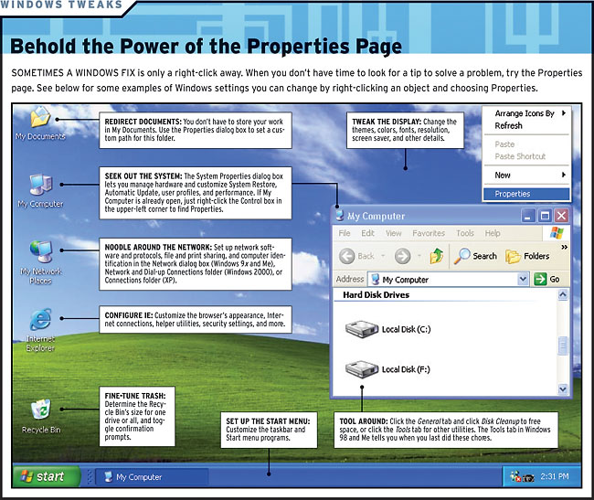
Examine the user advice under the Tips for New Users Section

Windows 2000 uses a different device driver model from Windows 9.x

See http://www.microsoft.com/windows2000/techinfo/planning/client/prousability.asp

Exercise 2: Creating a customized MMC

- Click Start->Run and type mmc , click OK. MMC starts and displays an empty console
- To view currently configured options, click Options on Console menu.
The default console mode is Author mode.
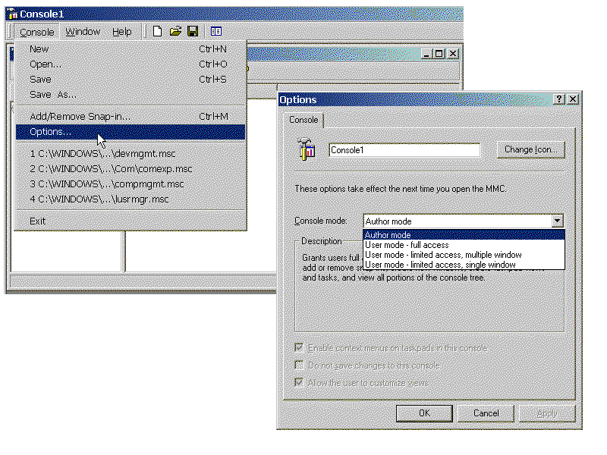

What other modes are available? _______________________ __________________________________________________

- Click Add/Remove Snap-In on the Console Menu
Click the Add button and notice the list of available Snap-Ins. Select the Disk Management snapin for the local computer. Click Finish, then Close, then OK. Notice that the Disk Management Snap-In appears in theAd/Remove Snap-In dialog box and in the Console Root.
- Click Save As on the Console Menu and type disk management. Note the default path (to the Administrative Tools folder), then save the Snap-In on the Desktop

Exercise 3: Using the Task Scheduler to schedule a reminder

- Open the Control Panel and go to Scheduled Tasks->Add Scheduled Task. Click Next. Choose Notepad, located in the \WINNT folder with the Browse button and set the task to run daily at 10Am every day. Enter your username and password. Note the Advanced options checkmark on the last screen, but for now, leave it blank and click Finish.
- Go to the Scheduled Tasks option in Control Panel, right-click on the Notepad task and click Run. When the blank Notepad window opens, enter the heading "My Daily Schedule." Underneath that, enter the text "Reminder -- Second W2K class meets Monday, November 4." Save this document in the "My Documents" folder.
- Go back to the Scheduled Tasks option in Control Panel, choose the Notepad task and open its properties. Change the command-line to read "Notepad schedule.txt," so that the file will be opened automatically, and make C:\My Documents the startup directory. Change the startup time to be one minute from the present time and save the task.

Exercise 4: Viewing Registry Information and Saving the Registry
- Log on locally as an administrator and choose Start->Run Regedt32
On the options menu, set the editor to Read Only mode from the Options menu.
- Select Tree and Data from the View Menu and maximize the HKEY_LOCAL_MACHINE hive.
- Go to the HARDWARE\RESOURCEMAP\Hardware Abstraction Laye3r subkey. What HAL is installed? ______________________________________
- Doubleclick the HARDWARE\DESCRIPTION\SYSTEM\CentralProcessor subkey and look at the settings under 0 to determine the type of processor in the computer.
- Click on the toplevel of HKEY_LOCAL_MACHINE and select Find from the View menu. Enter the word Windows and click Find Next. Click Find Next several times to see that there are a number of keys that contain the word "Windows."
- Go to the HKEY_LOCAL_MACHINE\SOFTWARE\Microsoft\Windows\CurrentVersion subkey and observe the entries underneath in the Run subkey. Then go to HKEY_LOCAL_MACHINE\SOFTWARE\Microsoft\Windows NT\CurrentVersion and observe the serial number and registered user information.
- Close Regedt32 and open the other Windows Registry Editor. (Choose Start->Run->Regedit
- Note that Regedit allows you to export and save the entire Windows registry from the Registry menu.

Exercise 5: Activating the Windows Recovery Console
See: http://www.techtutorials.com/tutorials/2000/win2kpro.shtml#rconsole
Insert the installation CD and switch to the I386 directory. Type C:\>winnt32 /cmdcons. When asked for confirmation, answer "yes". The file will be copied to the hard disk. After rebooting the computer you will be able to select "Microsoft Windows 2000 Command Console" and start Windows 2000 in command mode.

Exercise 6: Installing Windows 2000 Professional

See main handout. We will attempt to install Windows 2000 Professional on some of the practice computers at the back of the lab.

------------------------------------------

Using the Network

Instructor demonstrates network architecture: network adapter, cable, hub
10base T and 10base 2

Exercise 7: Network File Sharing Exercises

- Open My Network Places
browse computers, identify icons (workgroup, entire network.
- Read Access: Connect to shared My Documents Folder on instructor computer. Open File.
Copy file from shared My Documents folder to local hard disk.
Open file in My Documents through application. Attempt to save it to network folder (will fail)
Write access: Students create document with their own name on their desktops and copy to shared folder on Instructor computer.
- Students examine My Network Places and verify that File and Printer Sharing is installed on their local computers. (If already installed, may remove and reboot.)
- Students partner up. Each creates a shared folder on the desktop. with password protected full access.
a) each student creates a document within their own folder with their own name and signs it.
b) each student accesses the document on their partner's computer and signs in, resaving the document.
- Connecting to a shared printer: each student connects to the shared Printer on the Instructor's workstation. Attempt to print document.
- Creating a shared printer: each student creates a shared printer on their own workstation.

- See http://www.techtutorials.com/tutorials/2000/win2kpro.shtml#permissions
for information about NTFS File permissions

Exercise 8: Network Setup
Examine My Network Places, (right-click, properties). Observe basic components.

Instructor demonstrates client and protocol settings. (TCP/IP)

Students go to side computers, remove network configuration and reinstall. Observe procedures for testing physical network and software configuration.

- Right-click My Network Places – observe components
- Close My Network Places, right-click My Computer and open its Properties
- Select TCP/IP protocl and open its Properties
- Copy down the following information about the TCP/IP configuration:
Your computer’s assigned IP address and subnet mask (mine are 130.212.8.67
and 255.255.255.0)
The SFSU Gateway address (130.212.8.254)

The SFSU Domain Name Server configuration:

Host: Yourcomputer Domain: sfsu.edu
DNS Server Search Order:
130.212.10.163
130.212.10.162
You’ll need this information later on, when you rebuild the network configuration for your computer.

- Go to the Device Manager tab and expand the Network section
- Observe the listing for the NIC, highlight it and choose remove.
- Shut down the computer.

The computer is now in roughly the state that it would be in if you were installing a network card for the first time. We’re going to skip the actual insertion of hardware
- Turn on the computer. In most cases, Win95/98 plug and play will automatically detect the network card.
- Windows may ask you to insert a driver disk or automatically install a driver for the network card. You will be prompted to reboot the computer.
- Before rebooting, right-click My Network Places, open its properties and inspect the Components list.

