SAN FRANCISCO STATE UNIVERSITY – COLLEGE OF EXTENDED LEARNING
Information Technology Program
Lenny Bailes, Instructor
Windows NT Server (9947)
Summer 2001

Remaining class sessions: Thursday, July 19 6-9:30pm and one additional session to be determined in class:
Either Sunday, July. 22, 9:30am- 12:30pm or Friday eve., Jul. 27, 6-9:30PM

Windows NT Class Homepage
http://www.ccnet.com/~lennyb/sfsu/

Special Edition -- Using Windows NT Server 4.0 (online version of printed self-help book)
http://romana.geostar.ro/Special%20Edition%20Using%20Windows%20NT%20Server%204.0/index.htm

*More free books online at:
http://www.informit.com
(See, especially, Building an Intranet with Windows NT4, Chapters 6 and 7)

Microsoft Windows NT Homepage -- Overviews and Thumbnails
http://www.microsoft.com/catalog/display.asp?site=427&subid=22

Microsoft Windows NT Product Homepage -- contains more detailed information for MIS & Executives
Executive Overview -- Feature List and Marketing Arguments http://www.microsoft.com/ntserver/nts/default.asp

DeAnza College Windows NT Distance Learning Course
http://ntclass.deanza.fhda.edu/

Zone Alarm: a good, free, software firewall: http://www.zonealarm.com

Printed Resources:
Windows NT Administration Kit and Windows NT Technical Support Kit
Microsoft Press (includes tutorials, videos, + 120-day version of Windows NT Server)
Administration: ISBN # 1-57231-439-7 Tech Support: ISBN # 1-57231-373-0

Objectives:

1. Build simple navigation and administrative skills with Windows NT 4 Server
in preparation for configuring and operating a website with Microsoft's Internet Information Server 4

- Log into NT as an ordinary user or an administrator
- Be able to create a user account in User Manager or through Microsoft's Administrative Wizard
- Use the Windows NT Security screen (Ctrl+Alt+Del) to change login options, password, log off, shut down, or kill programs with Task Manager
2. Learn basic principles of Windows NT installation and learn how to update Windows NT Server, post-installation to a working configuration:
- Download and install Windows NT Service Pack 6.0a
Install the Windows NT 4 Option Pack, which includes Internet Information Server, v. 4.0, and Internet Explorer v. 4.01 or later.
3. Open the demonstration and administrative websites built into IIS v. 4, learn how to access the built-in tutorials.

4. Gain an overview of the Performance Monitor and Network Monitor diagnostic tools built into Windows NT Server.

5. Become familiar with the basic administrative capabilities of the IIS v.4 administrative Management Console:

- Learn to modify the default website
- Gain overview of the IIS settings tabs: Websites, Operators, Performance, ISAPI Filters, Home Directories, Documents, Directory Security, HTTP Headers, Custom errors

Basic skills

Learn about Windows NT on TV (through DeAnza College Distance learning class)

Log into Windows NT 4 as an ordinary user and as an administrator
How to log into Windows NT
How to share a folder

Installation Review
Training simulation
Download and install Service Pack 6.0a
Iinstall the MS Option Pack

NT Installation

A basic overview of the Windows NT Server installation procedure is provided in the NT Training Kit installation simulation.

After basic installation, Windows NT Server must be upgraded with one of Microsoft's Service Packs, or many features will be buggy or remain inoperable. The most current Service Pack is Service Pack 6.0a. It can be downloaded from the Microsoft website at:
http://www.microsoft.com/ntserver/nts/downloads/recommended/SP6/allSP6.asp

Internet Information Server/Option Pack Installation

After a basic installation, Windows NT Server, v. 4 contains only a very primitive version of IIS, v. 2.0. It also contains only a very crude version of Internet Explorer. (IE v. 2.0 contains no support for frames, java, javascript, or ASP.

In order to use Internet Information Server, v. 4.0, you must a) install Internet Explorer, v. 4.01 or higher and b) install the Windows NT Option Pack, which also includes the Site Server, Transaction Server, and a number of other enterprise features,

A CD that includes Internet Explorer, v. 4.01 and the Windows NT Option Pack ships with most versions of Windows NT Server that were released into the marketplace after 1997. The CD may still be available from Microsoft as a $10 purchase (it used to be). Or, you can download and install IE and the Option Pack over the Internet through Microsoft's website.

Download the Option Pack at
http://www.microsoft.com/ntserver/nts/downloads/recommended/NT4OptPk/default.asp

Install Internet Explorer 4.01 or higher, first. When you start the Option Pack Setup program, you'll see the following screen:
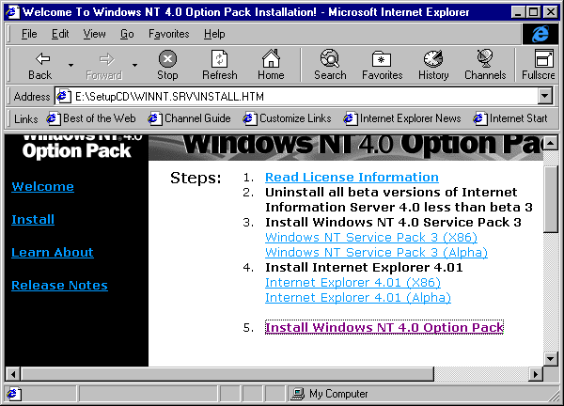

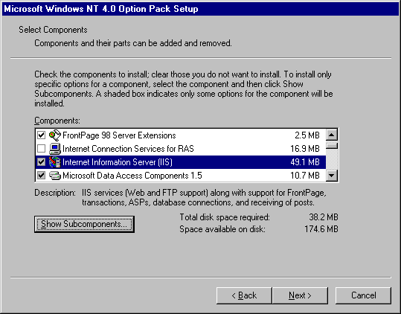
After clicking the Installation option, you'll see this screen:

Be sure to install the Microsoft Index Server to add search capabilities to your siteand Microsoft Management Console (not shown on this screen), Install the Windows Scripting Host if you plan applications that use VBScript, Transaction Server for commerce applications, Microsoft Site Server Express to perform site analysis and generate usage statistics. (See Microsoft's Windows NT Server website for more information about these features.

Each component in the list allows you to install subcomponents, just like the standard Windows Add/Remove Programs utility. You'll probably want to examine the subcomponents selected for Internet Information Server, since, by default, not all of the option features are installed.

If you click the Show subcomponents button for IIS, the next screen looks like this:
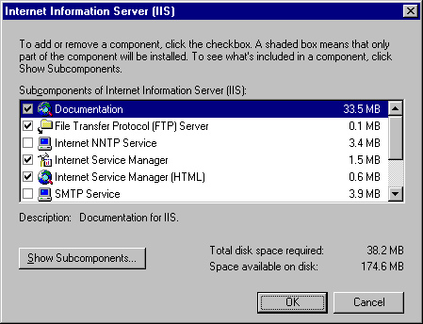
If you want to be able to run Microsoft's Multimedia tutorial demonstrations for IIS, then you'll need to open the subcomponents for Documentation and select the option to install the Multimedia demonstration files.

Logging into the Demonstration Website (Lab)

Open Internet Explorer . In the URL box, enter the address HTTP://LOCALHOST.

By default, the name LOCALHOST is assigned a built-in IP address of 127.0.0.1. You can access this address, and the demonstration website, even if the computer doesn't have a network card, or a real IP address assigned to a network device.

Change the entry in the URL box to HTTP://127.0.0.1

This is the default website that IIS installs on your computer. You can modify it, by changing the DEFAULT.HTM homepage, or create additional websites.

If Windows NT network services are properly configured, you can also access the demonstration website by entering the IP address bound to your network card, or the NETBIOS hostname for the computer.

Change the entry in the URL box to HTTP://130.212.56.xxx (see the sticker on your computer for the exact triplet in the final field.)

Change the entry in the URL box to HTTP://ITP_xx (where xx is the name assigned to your computer.

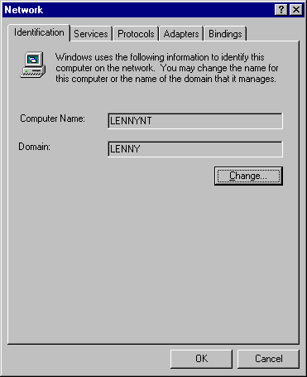
(To find the NETBIOS hostname assigned to your computer, right-click Network Neighborhood, open Properties and look on the Identification tab.
TCP/IP address are assigned through the Protocols tab:
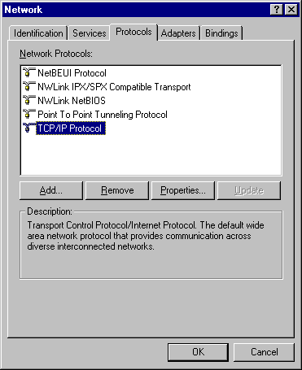
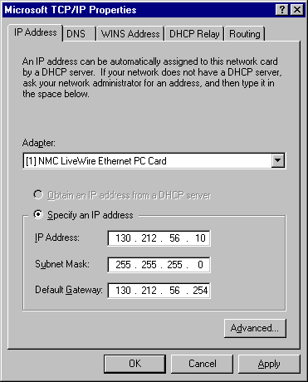
You should also be able to log onto another computer on the network (if it is properly configured) by entering its IP address or NETBIOS host name in the URL box.

Change the entry in the URL field to your neighbor's computer:
HTTP://ITP_xx

(We may want to review some basic networking concepts, here: Services, Protocols, TCP/IP, DHCP, DNS, WINS and we may also want to talk about the differences between workgroups and domains , and the difference between a Windows NT domain and an Internet domain, a NETBIOS hostname and an Internet domain name.)

Administrative website:

Internet Information Server, v. 4 also includes an administrative website that you can use to control the public websites, through the Internet Explorer web browser:

Enter the following address in the URL field: HTTP://LOCALHOST:4782.

Alternatively, you can manage IIS through a Microsoft Management Console.

Open the Internet Information Server MMC snapin in from the Start Menu, Administrative Tools group.
Miscellaneous Configuration Tips

Installing a sound card
Installing SCSI Peripherals (hard disks, CDRW/DVD, tape drives)

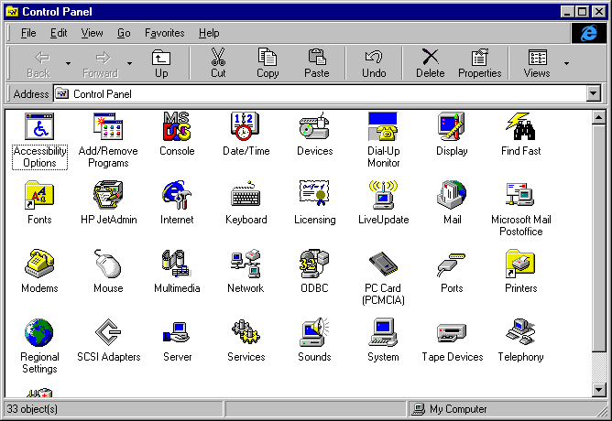
Windows NT Control Panel Notes

*=important applet:

Add/Remove Programs – similar to the applet in Windows 98: adds and removes accessory applications.

Console – sets MS-DOS options

*Devices – presents list of installed hardware devices, allowing you to start and stop device drivers on a case-by-case basis

Dial-Up Monitor – dial up network diagnostics

Display – similar to Windows 98: sets video display options

Internet – similar to Windows 98, controls Internet Explorer and Internet Dialup options.

*Network – controls hardware/software network settings. Much more complex than Windows 98
Important services:
RAS – remote access service to let users dial in to network via modem
IIS Internet Information Server – web server
DHCP – Dynamic Host Control Protocol – automatically assigns IP addresses to client machines
WINS – Windows Internet Naming Service – matches IP numerical addresses with NETBIOS
names (proprietary Microsoft service)
DNS Domain Name Services – matches IP numerical addresses with computer names
this is a more general naming service that complies with UNIX and other platform
standards

Multimedia: Lets you control multimedia settings, add and remove multimedia devices (such as a sound card)

SCSI Adapters – controls ordinary ATAPI (IDE) CD-ROM devices and tape backup as well as SCSI CD-ROMS, hard disks and other peripherals.

Server – provides status on currently shared folders and users logged into the domain

*Services – lists all currently running Windows NT services, allowing you to start and stop them manually
or automatically.
*System – controls Windows NT startup options. Controls paging(swap) file and offers some diagnostic
information.

Get more help with Windows NT

Insert Windows NT Server CD in CD-ROM drive.
Choose \SUPPORT\BOOK folder and double-click Server icon.

Exercise: Getting Help with IIS

- Open the IIS Manager from the NT Option Pack -> Microsoft IIS program group
- Click on Help on Internet Information Server on the Help menu
- We will view some of the multimedia tours in class: (quick tour of features)

IIS offers:

Web services, including Active Server Pages, Database Queries, Indexing and Search capabilities
(you can also script with ISAPA and CGI
Transaction Server
Powerful security features (Challenge/Response and Certificate Server)
NNTP (Usenet News Services)
SMTP (Simple Mail Transport Protocol, Mail Services)
FTP (File Transfer Protocol)

Exercise: Open Default Website
(we may need to copy files in class)
Go to default website in IIS Manager, right-click and choose browse.
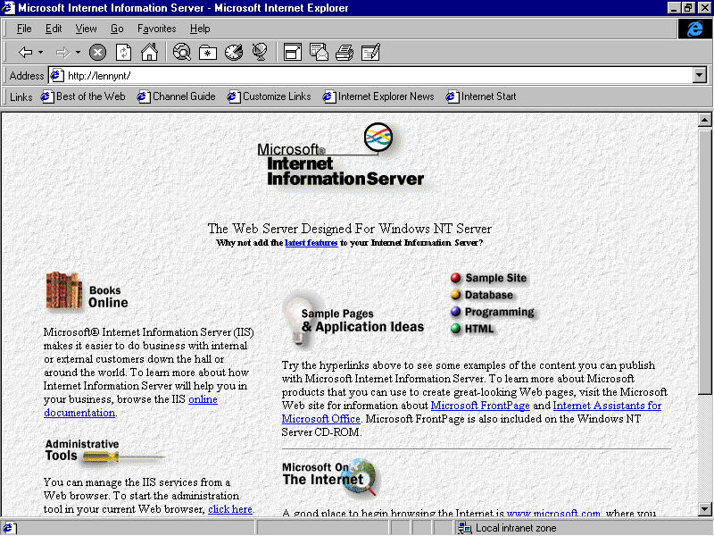

Understanding \INETPUB directory structure (Browse versus Open)
Introduction to IIS features through sample website:
Sample pages and applications
Database queries (if SQL Server is running)
Microsoft Index Server overview
HTML Style examples
Programming (ISAPI applications and filters)
Adding HTML pages and other files to a website

Exercises: IIS Management Options
FTP, Host, Port, and other Web Configuration options
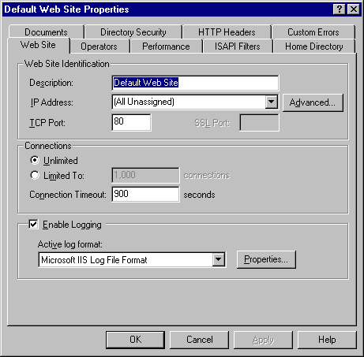

Virtual Websites

Review

